

Assessment Guide

Module Code | CPU4:103
Module Name | Introduction to Database
Module Leader | Puna-Rimam Maiyaki
Cohort | June 2025
Assessment component(s) | Collaborative database build with individual report and recorded presentation
Restrictions on time/word count | 1,500 words +- 10%
Individual/group | Group
Assessment weighting(s) | Individual report 50% | Individual presentation and code verification 50%
Hand in date(s) | 09/11/2026
Student ID | G1440425
Campus | GBS Leeds
Module Tutor | Cyncia Matsika
Word Count | 1470

Crownfield Eye Hospital Database
Individual Logbook
1. Introduction
This project involved designing and developing a relational database for Crownfield Eye Hospital. The purpose was to organise hospital information, including patient details, clinicians, appointments, diagnoses, presentations, medicines, and follow up plans. A relational database stores information in separate but connected tables, helping users manage data more efficiently (Connolly and Begg,2015).
Our group had three members. We worked together to understand the hospital requirements, develop the Entity Relationship Diagram (ERD), and complete normalisation. My main contribution was identifying the tables required for the database and helping to draw the relationships between them.
The database was implemented using MySQL Workbench. We used fictional hospital records instead of real patient information. This allowed us to demonstrate database design and testing without using confidential medical details.

2. Database Analysis and Design
At the beginning of the assignment, we examined the unnormalized hospital information and identified problems with the existing structure. Patient information, appointment details, and medicine information could appear together in one large table.
For example, when a patient attended several appointments, their name and postcode could be repeated. This creates a risk of update anomalies because changing one record might leave other records containing outdated information. It can also cause insertion and deletion problems.
My main responsibility was identifying the entities and helping establish their relationships. After discussing the hospital requirements, our group selected 11 tables: Patient, Specialty, Clinician, Clinic, Appointment, Diagnosis, AppointmentDiagnosis, Prescription, Medicine, PrescriptionItem, and FollowUpPlan.
We identified the attributes required for each table. For example, the patient table contains PatientID, FirstName, LastName, and Postcode. PatientID is the primary key because it uniquely identifies each patient.
I helped identify the relationship between Patient and Appointment. One patient can have many appointments, but each appointment belongs to one patient. This is a one to many relationship. The Appointment table contains PatientID as a foreign key, connecting the appointment to the correct patient.
Foreign keys are important because they maintain relationships between tables and help prevent invalid references (Oracle,2024b).
Another important relationship was between Appointment and Diagnosis. An appointment. We used AppointmentDiagnosis as a connecting table to manage this many to many relationship.
I initially found this relationship difficult because I thought the two tables could be connected directly. After discussing it with the group, I understood why an additional table was needed. We used Crow’s Foot notation to show the relationships, including cardinality and optional participation. For example, a patient may have no appointments yet, while an appointment must be connected to a patient. The ER diagram helped us check the database structure before implementation.
Figure1: Crownfield Eye Hospital ER Diagram
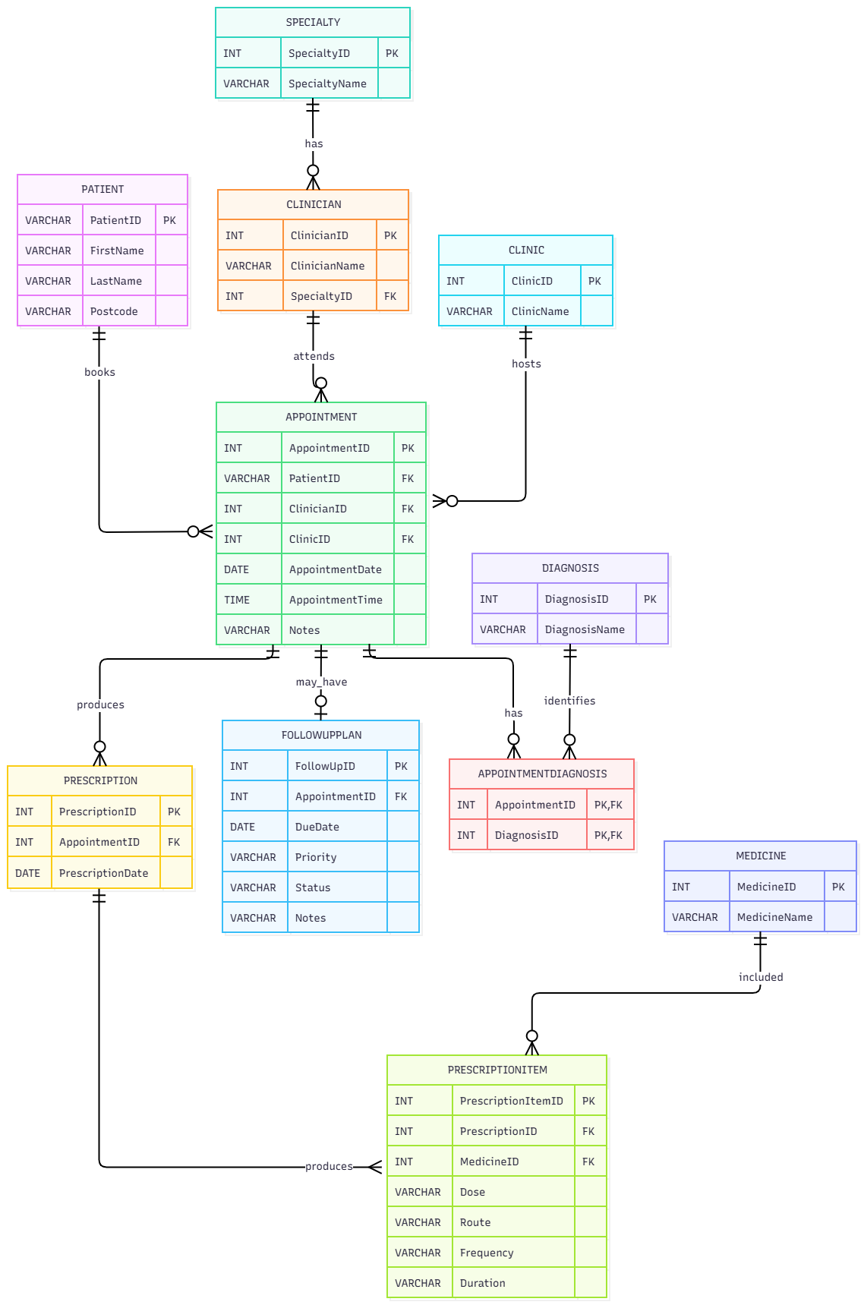
3. Database Normalisation
Normalisation was completed together by all three group members. It is used to organise data into related tables and reduce unnecessary duplication (Connolly and Begg,2015). We started with Unnormalised Form (UNF). The original hospital information contained repeated patient details and multiple items associated with appointments and prescriptions.
In First Normal Form (1NF), we removed repeating groups and organised the information so that each field contained one value. For example, medicine information needed to be represented as separate records instead of storing several medicines in one field.
In Second Normal Form (2NF), we checked for partial dependencies. A partial dependency happens when a non key attribute depends on only part of a composite primary key. We separate information where necessary so that attributes depended on the correct keys.
In Third Normal Form (3NF), we removed transitive dependencies. These occur when a non key attribute depends on another non key attribute instead of directly on the key. For example, clinician and specialty information were stored in separate tables to reduce repeated specialty details. Microsoft (n.d.) explains that normalisation improves consistency and makes database information easier to maintain.
The normalisation process helped me understand that creating a database is not only about storing information. The information must also be organised correctly to avoid problems later.
Figure2a : UNF- original repeating medicine value
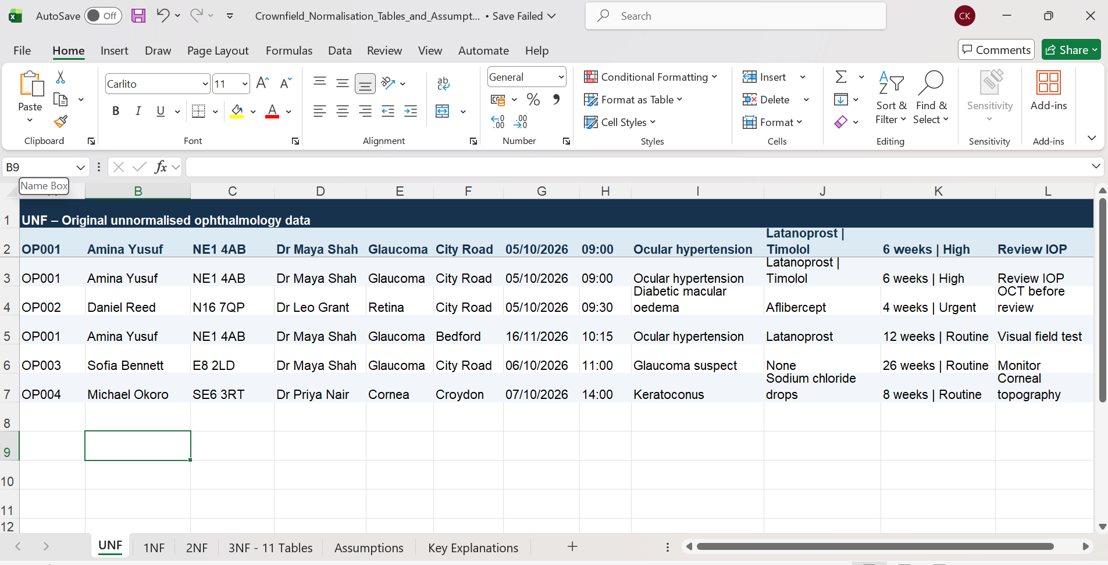

Figure 2b: 1NF- one medicine per row
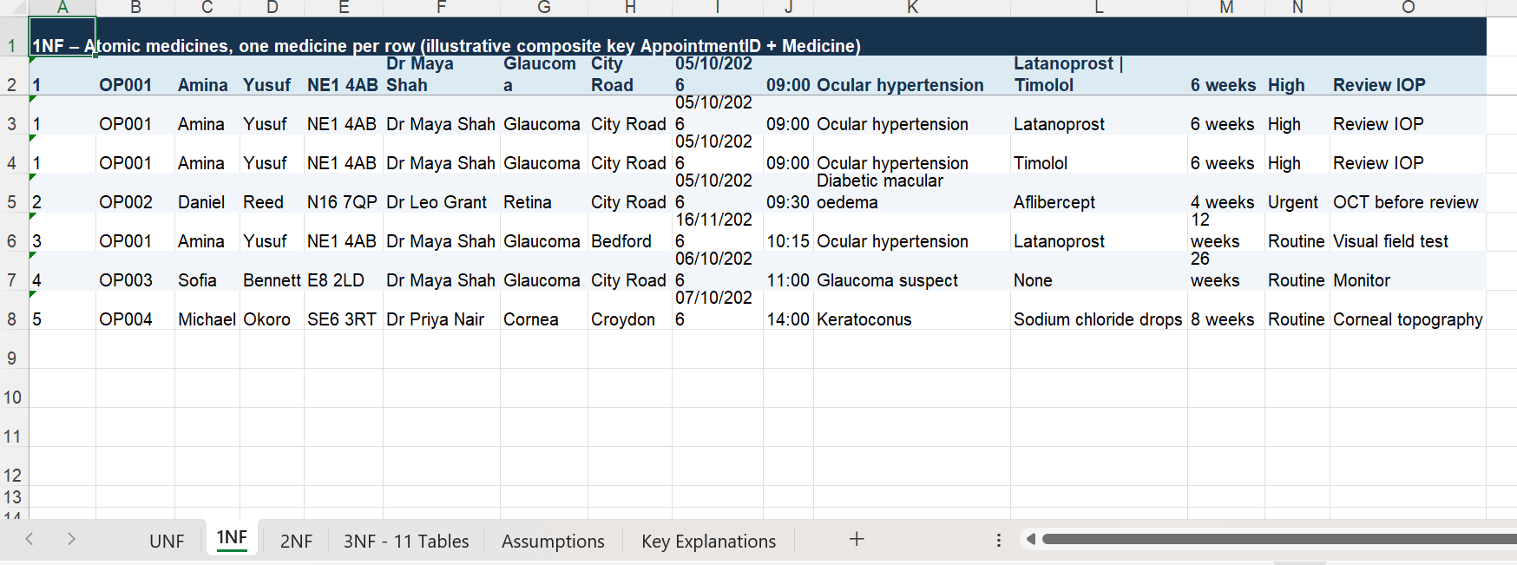

Figure 2c: 2NF- patient and appointment details separated
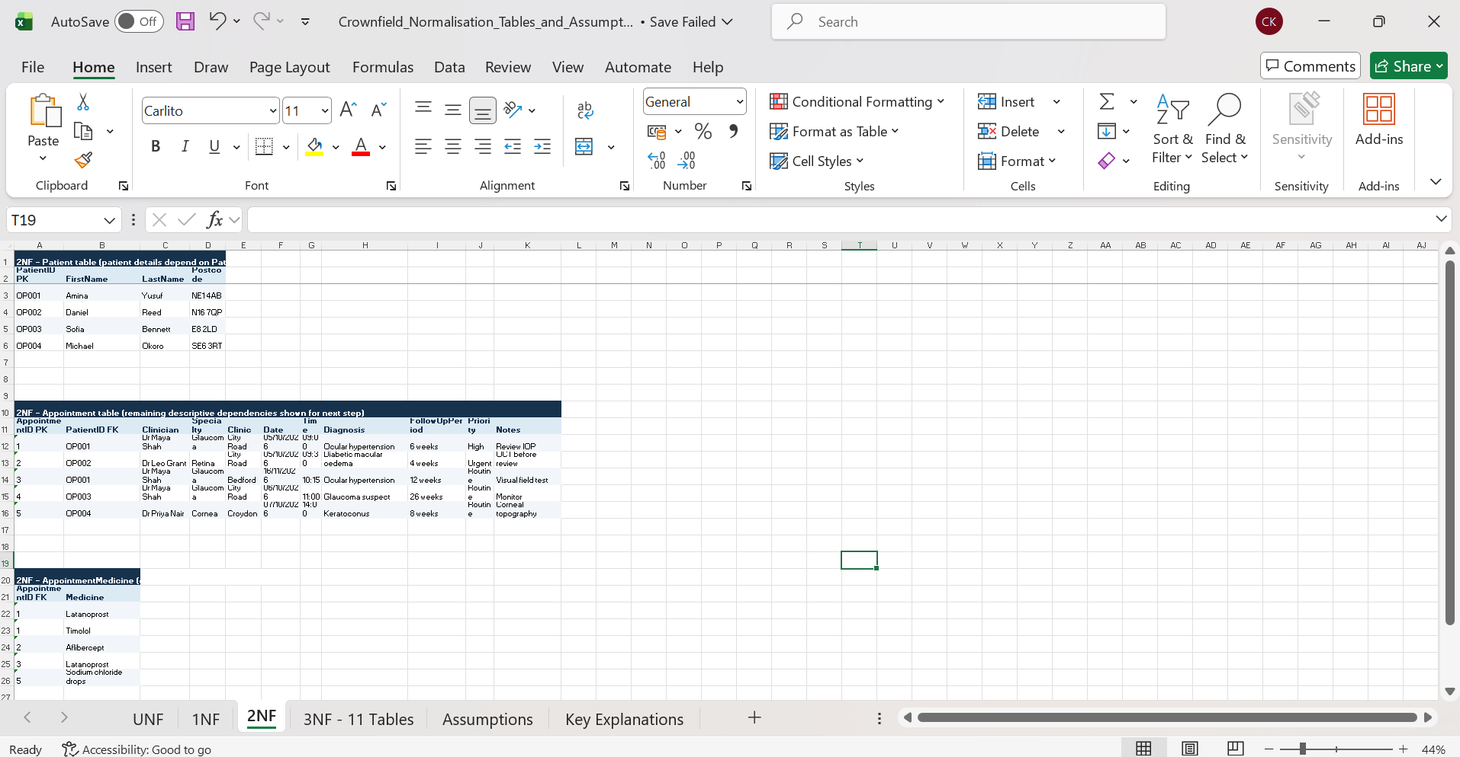

Figure 2d: Final 3NF tables – part 1of 2
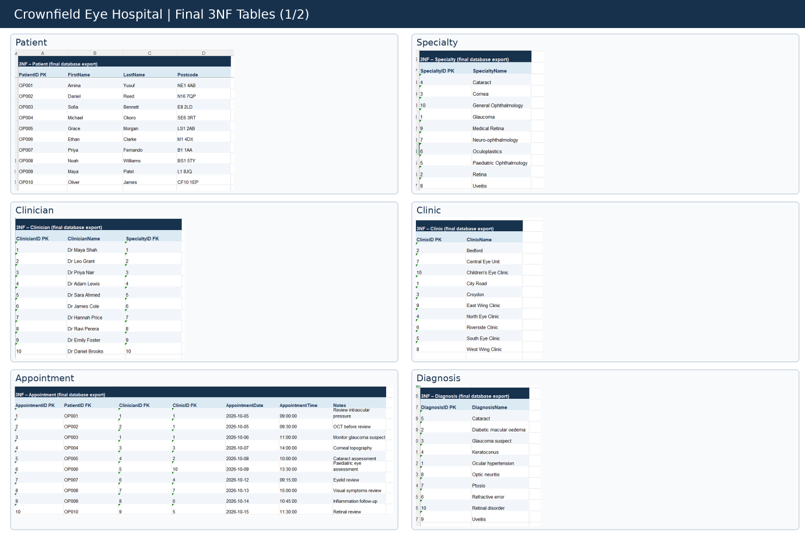
Figure 2e: Final 3NF tables – part 2of 2
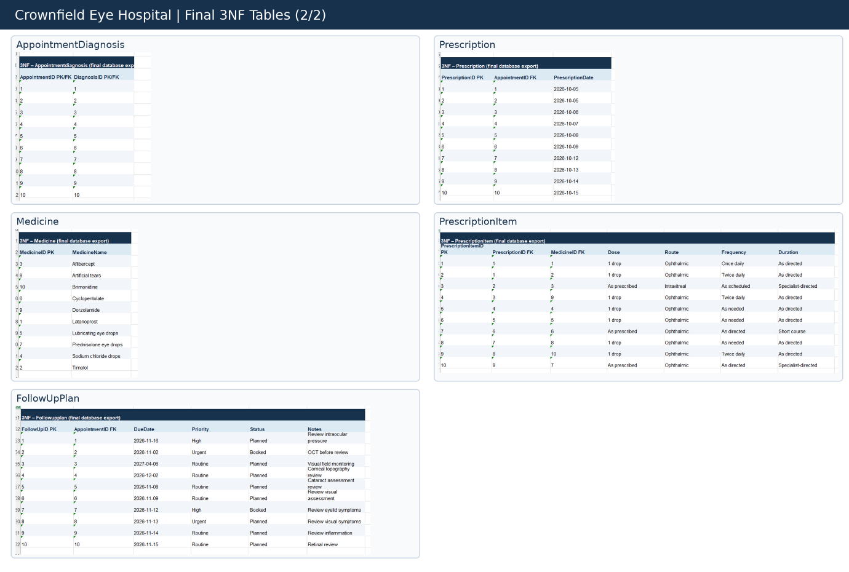

4. Database Implementation and Testing
After completing the design, we moved to implementation. One of my other group members took the main responsibility for creating the tables and inserting fictional records in MySQL Workbench. My design contribution was important during this stage because the relationships identified in the ER diagram were used to create the foreign key connections.
The database contained 11 related tables. Different data types were selected depending on the information stored. For example, INT was used for numerical identifiers, VARCHAR for names and postcodes, and DATE for dates. Constraints such as PRIMARY KEY, NOT NULL and UNIQUE were used to support data integrity. MySQL provides these constraints to help control the structure and validity of stored information (Oracle,2023a).
The database was populated with fictional information, including 10 patient records. We reviewed the table structure and SQL results to check whether the design had been implemented correctly. The testing evidence included screenshots showing the tables, patient records and query results. This stage helped me understand how the relationships in an ER diagram become working connections in a relational database.

Figure 3: Patient records with first and last names

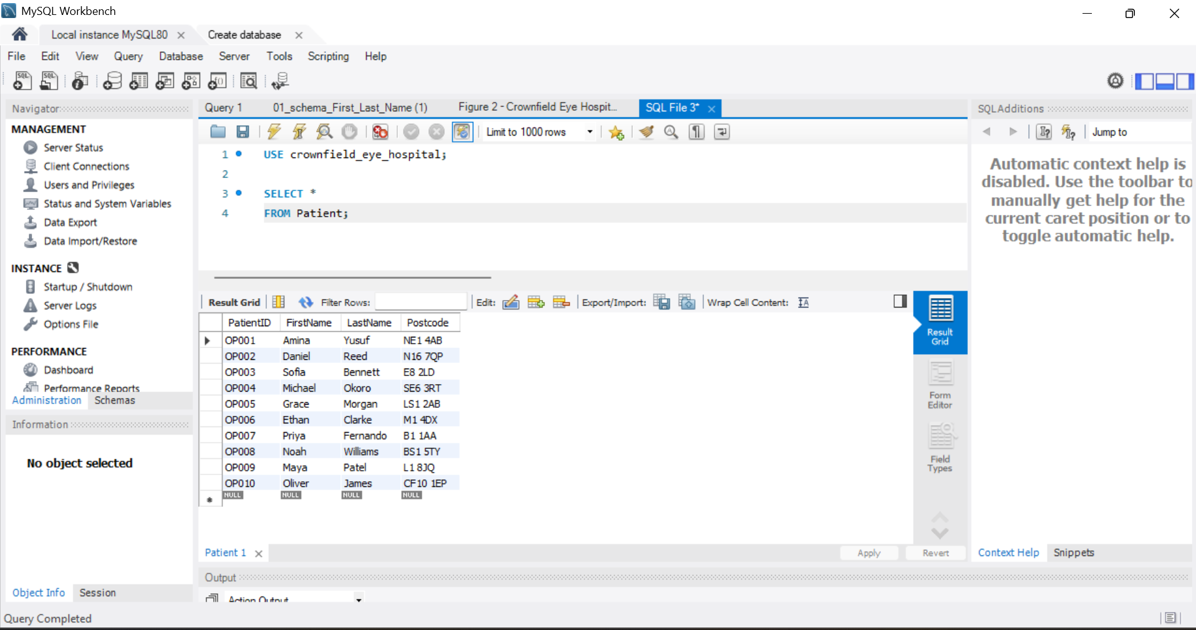

Figure 4: Crownfield Eye Hospital database tables

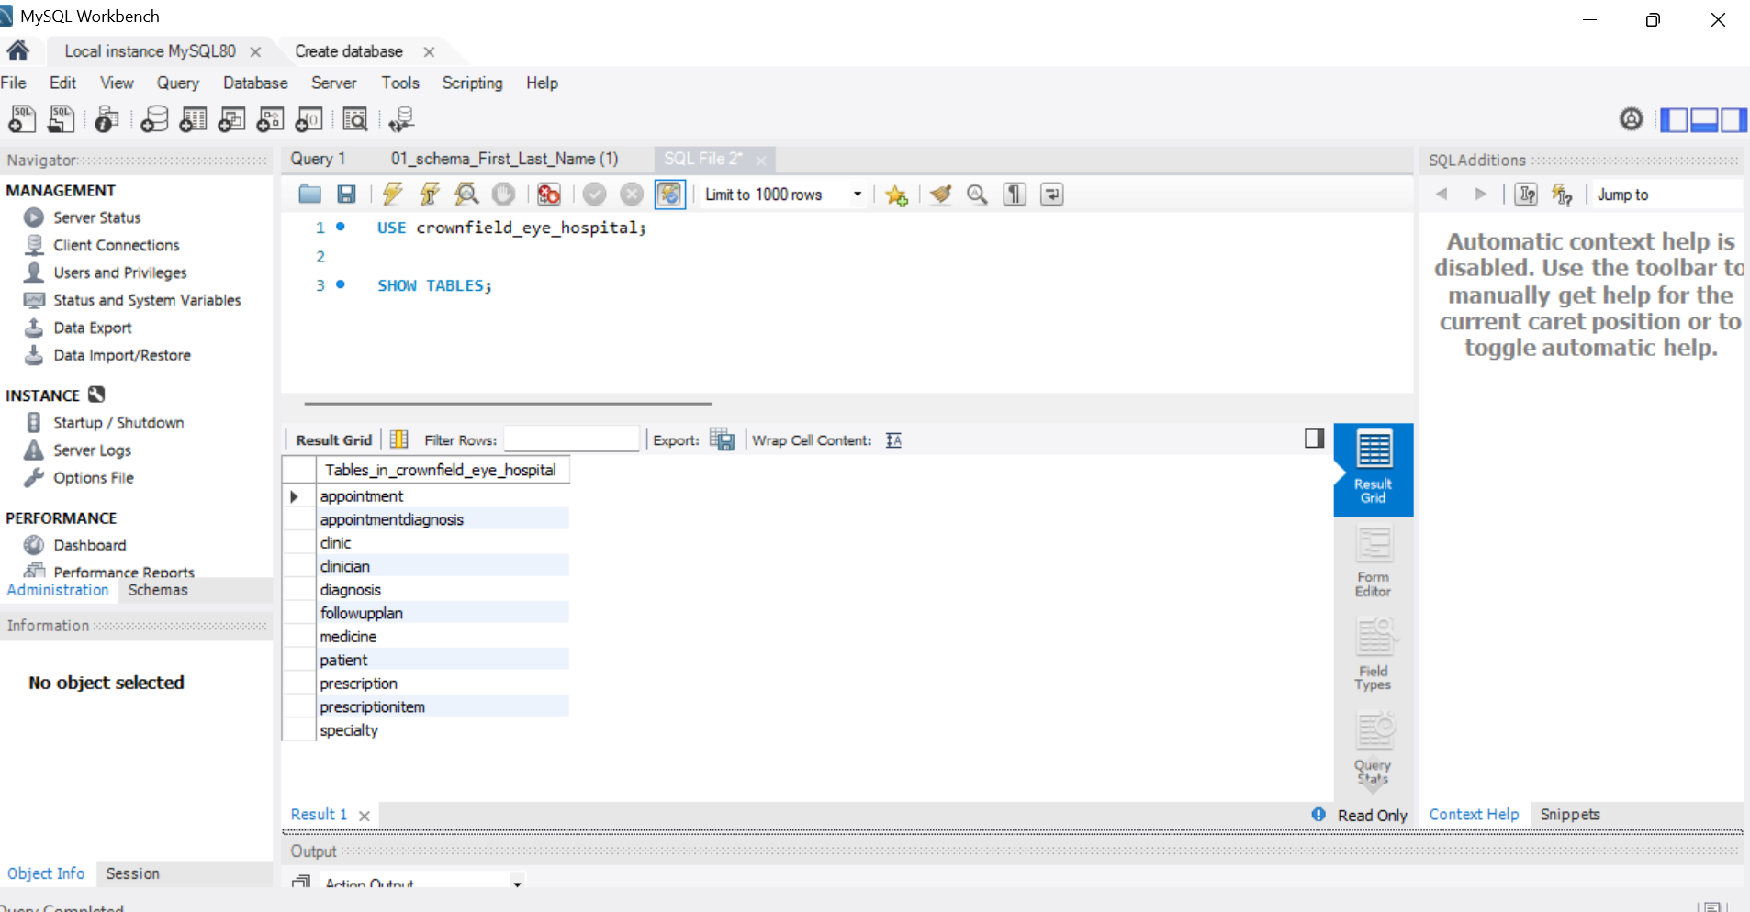
5. SQL Queries and Database Features
SQL was used to retrieve information and test different database features. As part of my individual work, I developed and tested six SQL features using MySQL Workbench.
Firstly, I used INNER JOIN to connect the Patient, Appointment, and Clinician tables. This allowed me to display patient names, appointment dates, and the clinicians responsible for the appointments. Figure 5 shows the result.

Figure 5: INNER JOIN testing
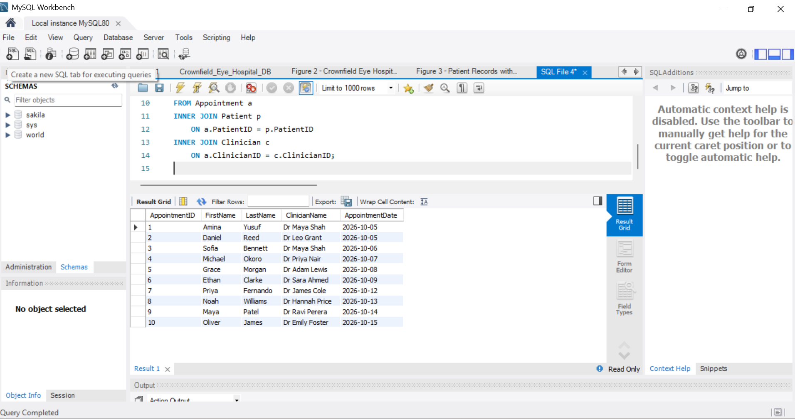
I used LEFT JOIN to display appointments with their follow up information. This also included appointments without a follow up plan, as shown in Figure 6.
Figure 6: LEFT JOIN testing
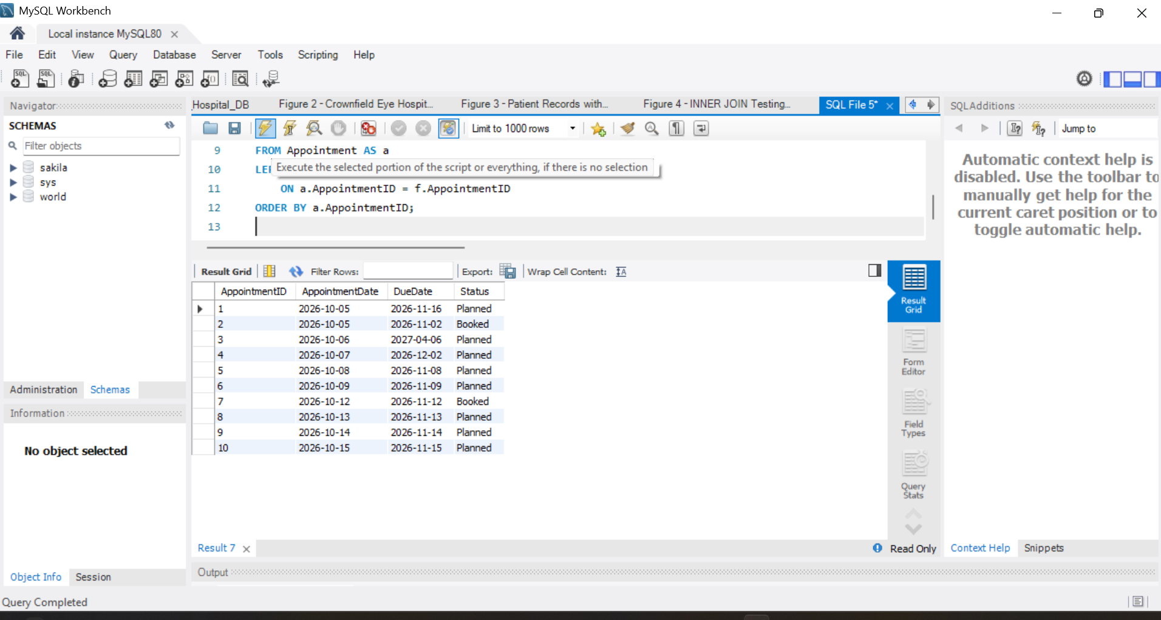
I used GROUP BY and HAVING to count appointments for each clinician and filter the group results. Figure 7 shows the query result.

Figure 7: GROUP BY and HAVING testing
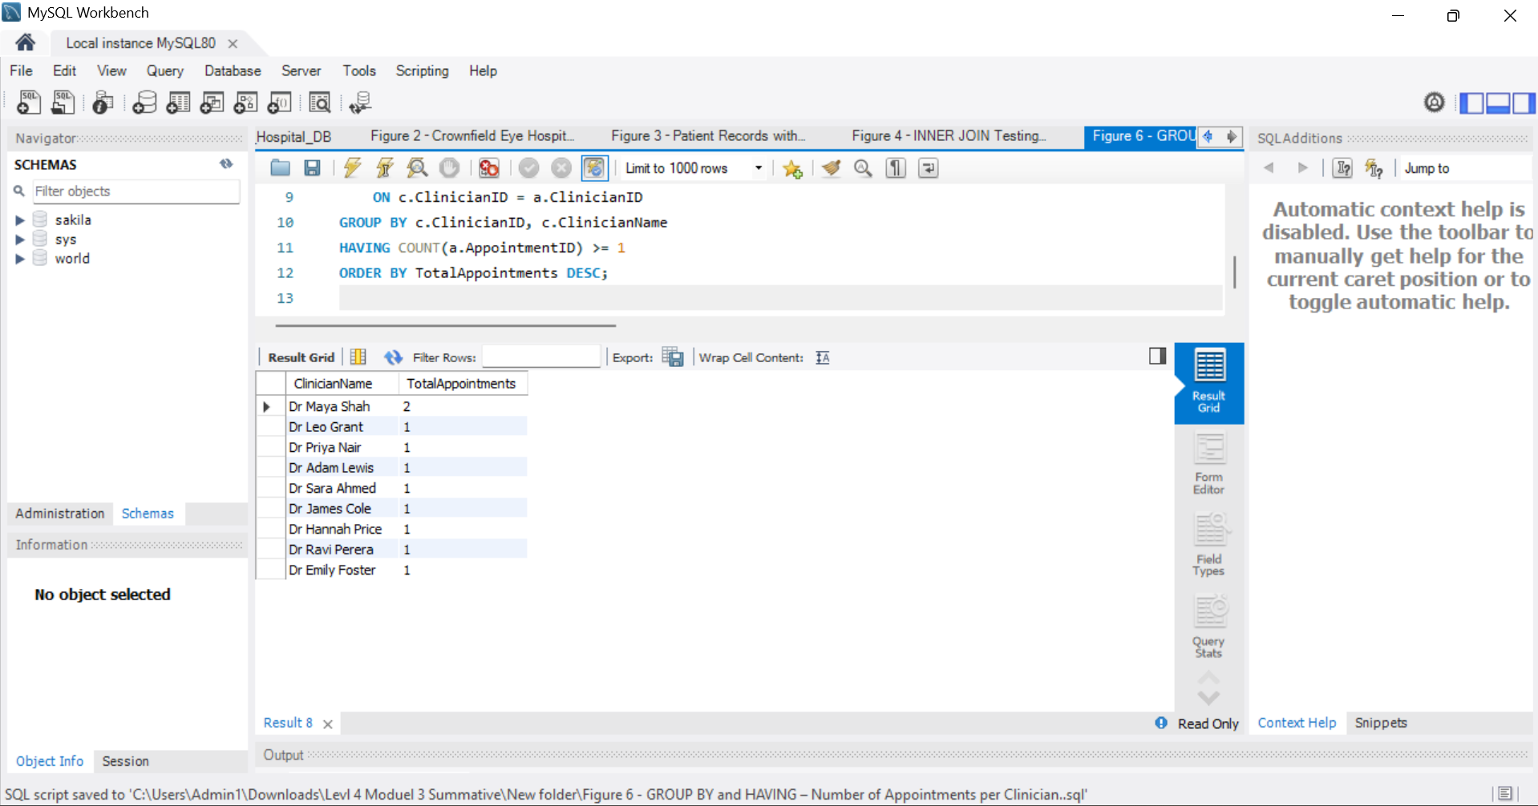
I also used a subquery to find patients who had appointments with Dr Maya Shah. This helped me understand how one query can use information from another query. Figure 8 shows the result.
Figure 8: Subquery testing – patients who saw Dr Maya Shah
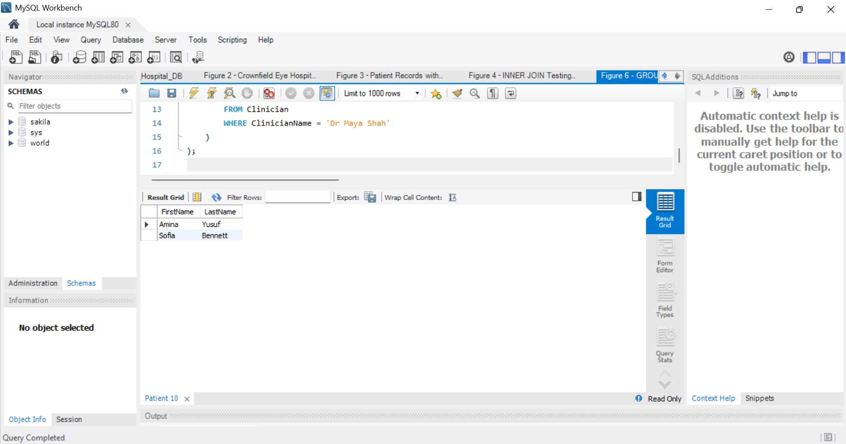
The project stored procedure GetClinicianAppointments takes a clinician ID as an input parameter. The successful test CALL GetClinicianAppointments(1) returned two appointments, for Amina Yusuf and Sofia Bennett. Figure 9 shows the MySQL result. The repository contains the matching corrected SQL file.
Figure 9: Stored procedure testing – GetClinicianAppointments
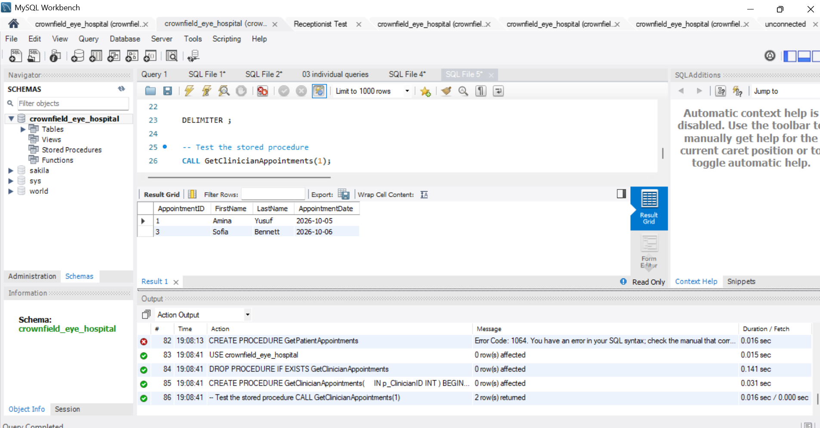
Finally, I tested a trigger called CheckFollowUpDate to prevent an invalid follow up date from being entered. When I tried to enter a follow up date earlier than the appointment date, MySQL returned an error. Figure 10 shows this test.
Figure 10: Trigger testing – CheckFollowUpDate
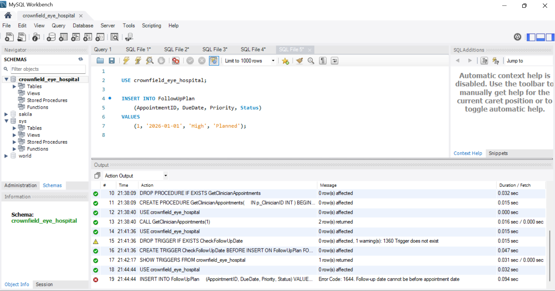
These six SQL features helped me understand how SQL can retrieve information and maintain data accuracy (Oracle, 2024a). The SQL scripts and testing evidence are included in my individual GitHub repository.

6. Database Security and Transactions
Database security is important because hospital information should only be accessed by authorised users. Our database included four user roles: Administrator, Doctor, Receptionist and Patient. Each role had different permissions depending on the information they needed to access. The Administrator had wider access to manage the database, while the Receptionist had more limited permissions for appointment related tasks.
I tested database permissions to check whether users could access the correct information. One test showed that the receptionist account was denied access to diagnosis information. This demonstrated how access controls can help protect sensitive information (National Institute of Standards and Technology, 2020).
I also tested hashing to understand how a sensitive value can be changed into a fixed length hash value using a one way function. For transaction testing, I used COMMIT and ROLLBACK. COMMIT saved the changes made during a transaction, while ROLLBACK cancelled changes that had not been committed.
These tests helped me understand how database security and transactions protect information and maintain data consistency. Figure 11 shows the role-permission evidence.

Figure 11: Receptionist role permissions in MySQL
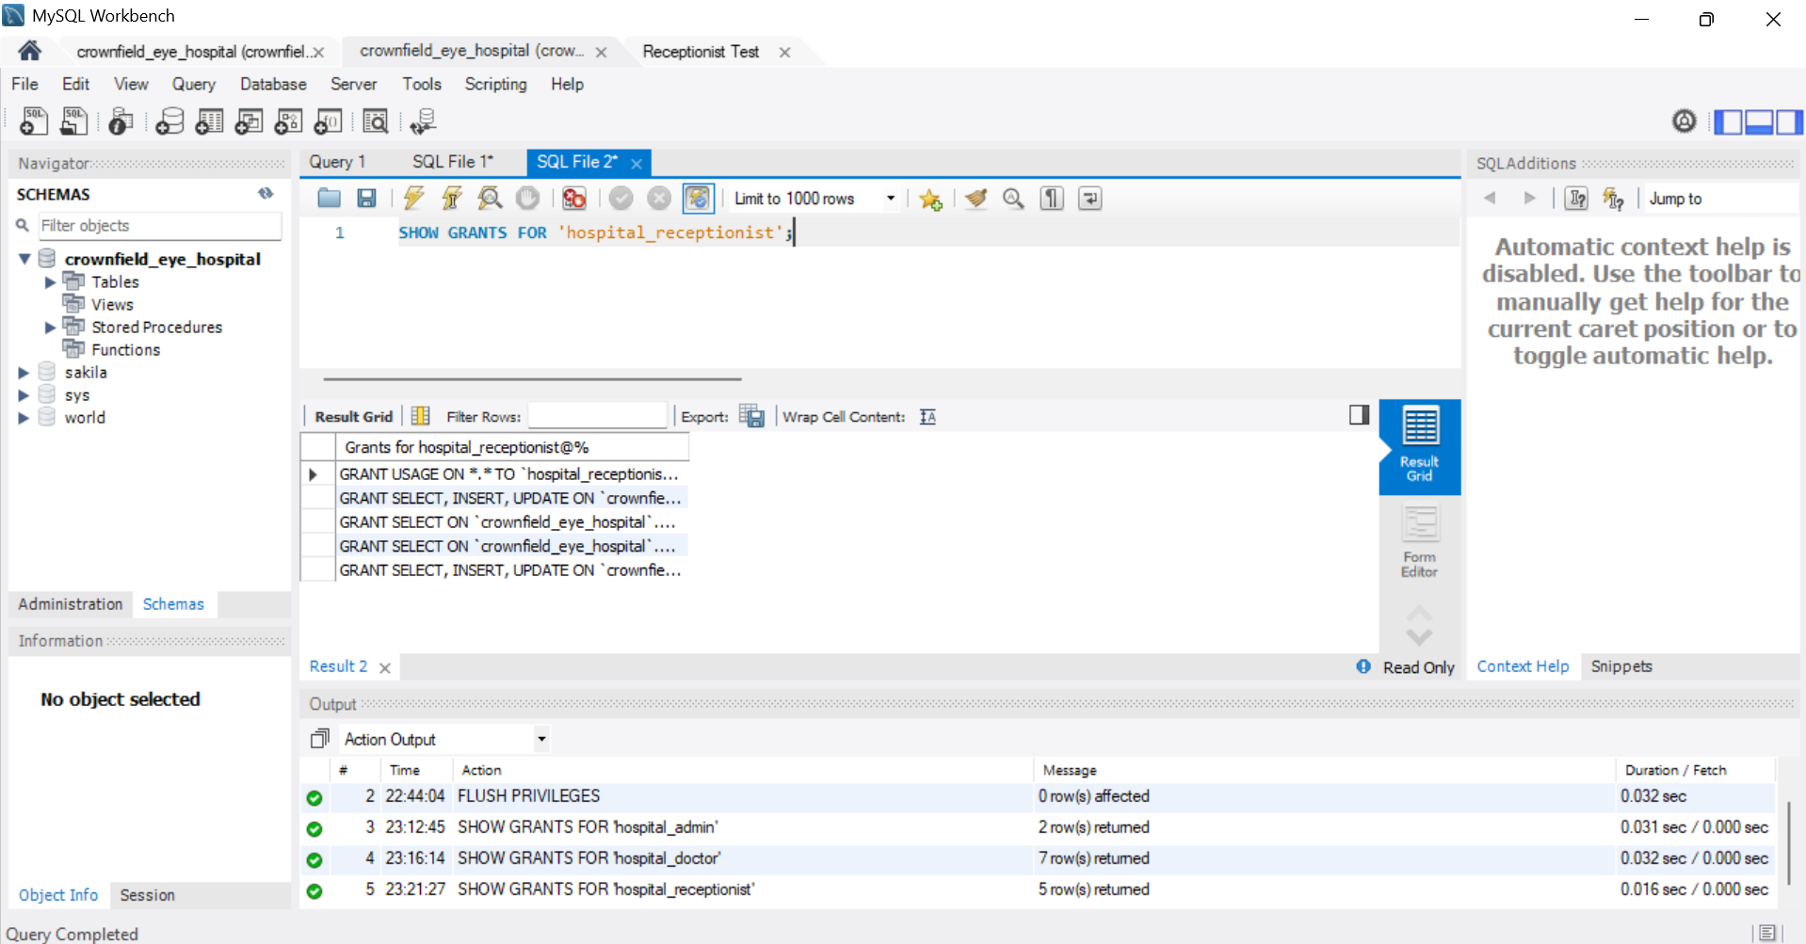

Figure 12: Hashing demonstration
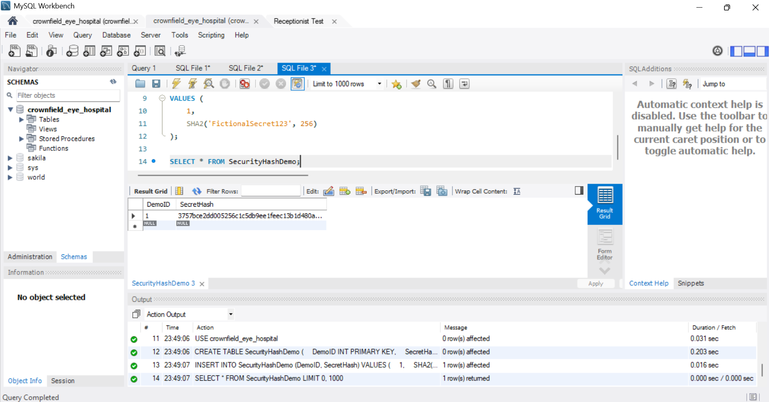

Figure 13: COMMIT transaction test – patient postcode updated
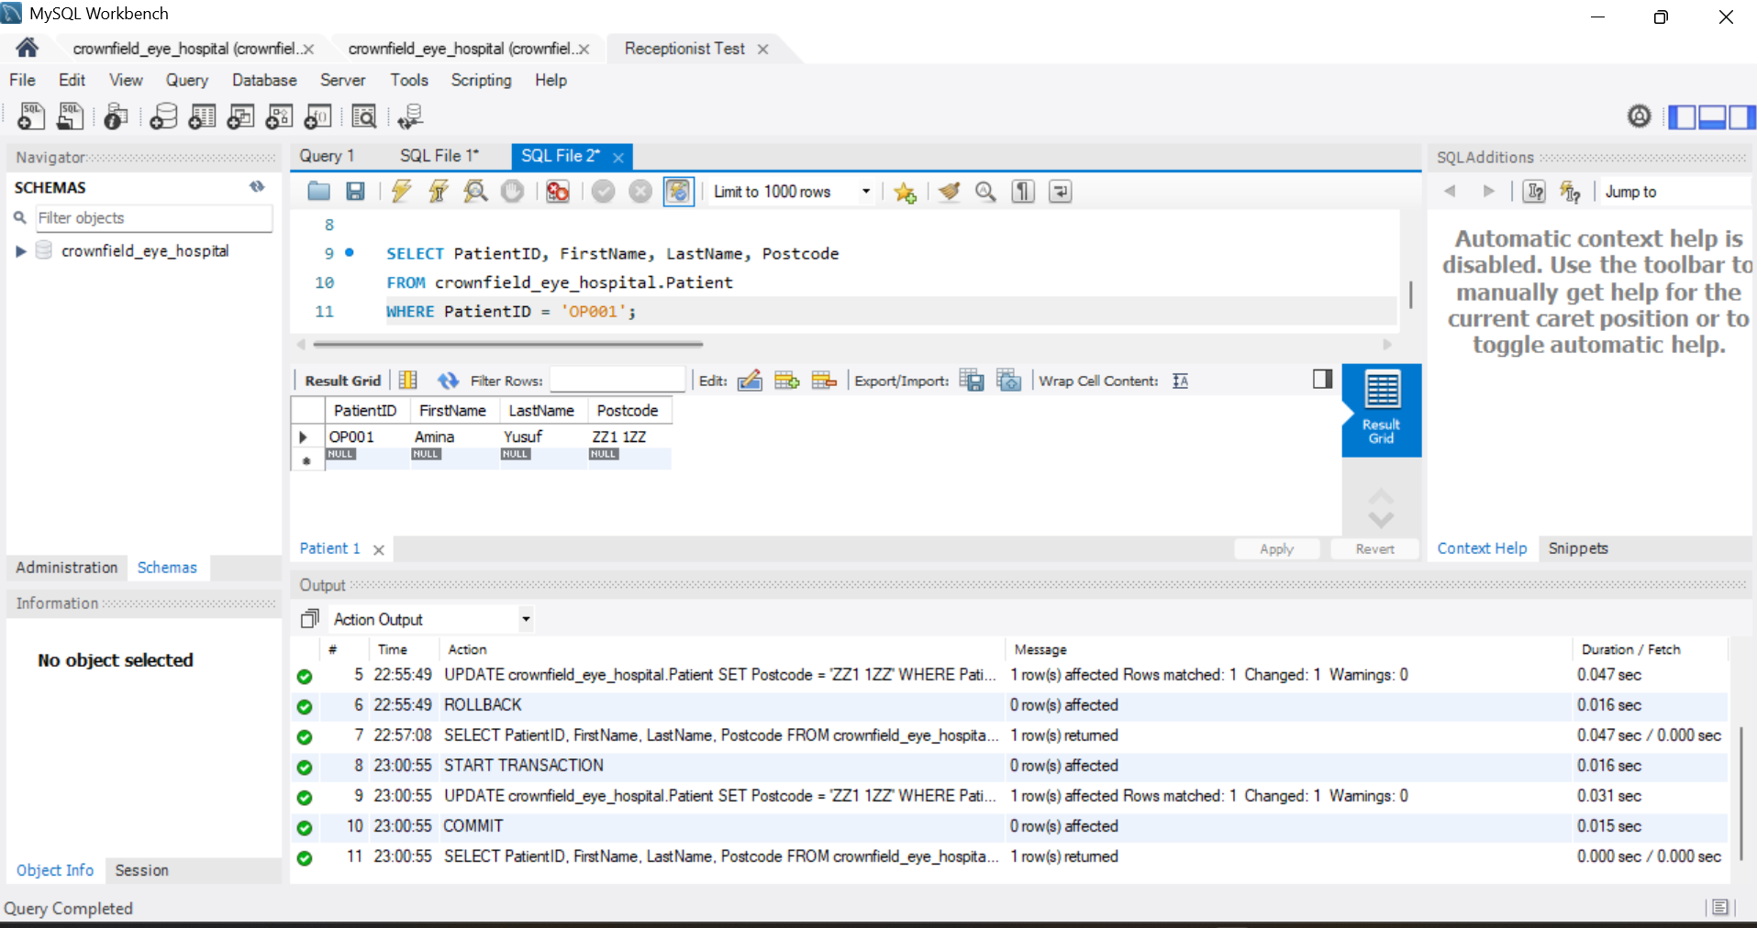
Figure 14: ROLLBACK transaction test – original patient postcode restored
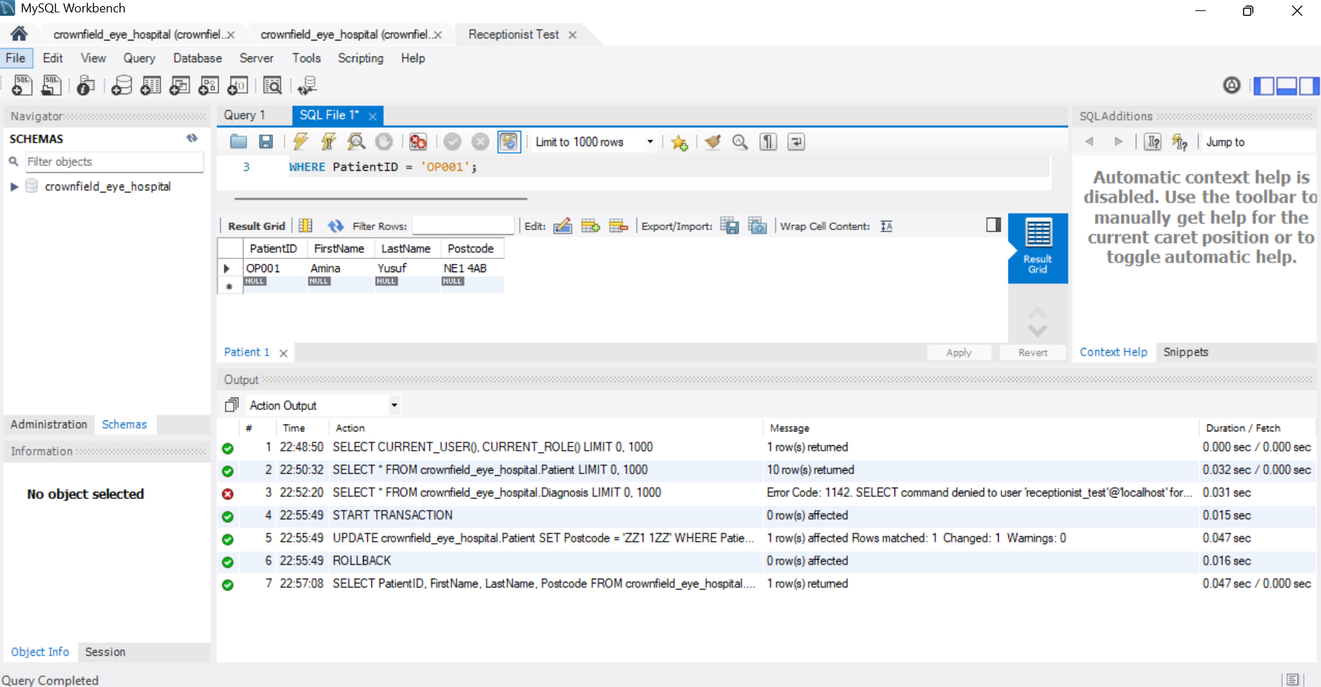

7. Evaluation and personal Reflection
This assignment helped me understand how relational databases are designed and why relationships between tables are important. My main contribution was identifying the tables in the database. One area I found difficult was understanding many to many relationships. At first, I was unsure why AppointmentDiagnosis needed to be a separate table. After discussing this with my group, I understood how a connecting table works. I also developed and tested six SQL features, which helped me understand how SQL can retrieve information from different tables and check database rules.
Working with my group members helped me understand different ideas and improve our database design. I also learned the importance of normalisation because related information can create problems when records are updated or deleted.
One area I would improve is my time management. In future projects, I would start the design earlier and check the relationships before moving on to the implementation.
Overall, this assignment improved my understanding of database design, ER diagrams, normalisation, SQL queries, and database security.

References
Connolly, T. and Begg, C. (2015) Database Systems: A Practical Approach to Design, Implementation, and Management. 6th edn. Harlow: Pearson.
Microsoft (n.d.) Description of the database normalization basics. Available at: https://learn.microsoft.com/en-us/troubleshoot/microsoft-365-apps/access/database-normalization-description (Accessed: 7 November 2026).
National Institute of Standards and Technology (2020) Security and Privacy Controls for Information Systems and Organizations. NIST Special Publication 800-53, Revision 5. Available at: https://doi.org/10.6028/NIST.SP.800-53r5 (Accessed: 7 November 2026).
Oracle (2024a) MySQL 8.4 Reference Manual. Available at: https://dev.mysql.com/doc/refman/8.4/en/ (Accessed: 7 November 2026).
Oracle (2024b) MySQL 8.4 Reference Manual: FOREIGN KEY Constraints. Available at: https://dev.mysql.com/doc/refman/8.4/en/create-table-foreign-keys.html (Accessed: 7 November 2026).

